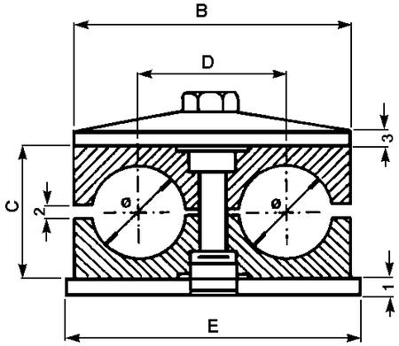

ITEM CODE | LENGTH MM | DIAMETER MM | A SIZE MM | B SIZE MM | C SIZE MM
02435 | 37 | 6 | 20 | 36 | 25
02436 | 37 | 8 | 20 | 36 | 25
02552 | 37 | 10 | 20 | 36 | 25
02533 | 37 | 12 | 20 | 36 | 25
02437 | 55 | 14 | 29 | 53 | 26
02553 | 55 | 15 | 29 | 53 | 26
02534 | 55 | 16 | 29 | 53 | 26
02554 | 55 | 18 | 29 | 53 | 26
02555 | 70 | 20 | 36 | 67 | 37
02535 | 70 | 22 | 36 | 67 | 37
02556 | 70 | 25 | 36 | 67 | 37
02536 | 85 | 28 | 45 | 82 | 42

